Final Module Hierarchy Chart (Structure Chart)
Role: Senior Software Architect (Structured Design)
Project: RescueLink – Real-Time Disaster Response & Rescue Coordination System

Final Module Hierarchy Chart (ASCII Structure Chart)
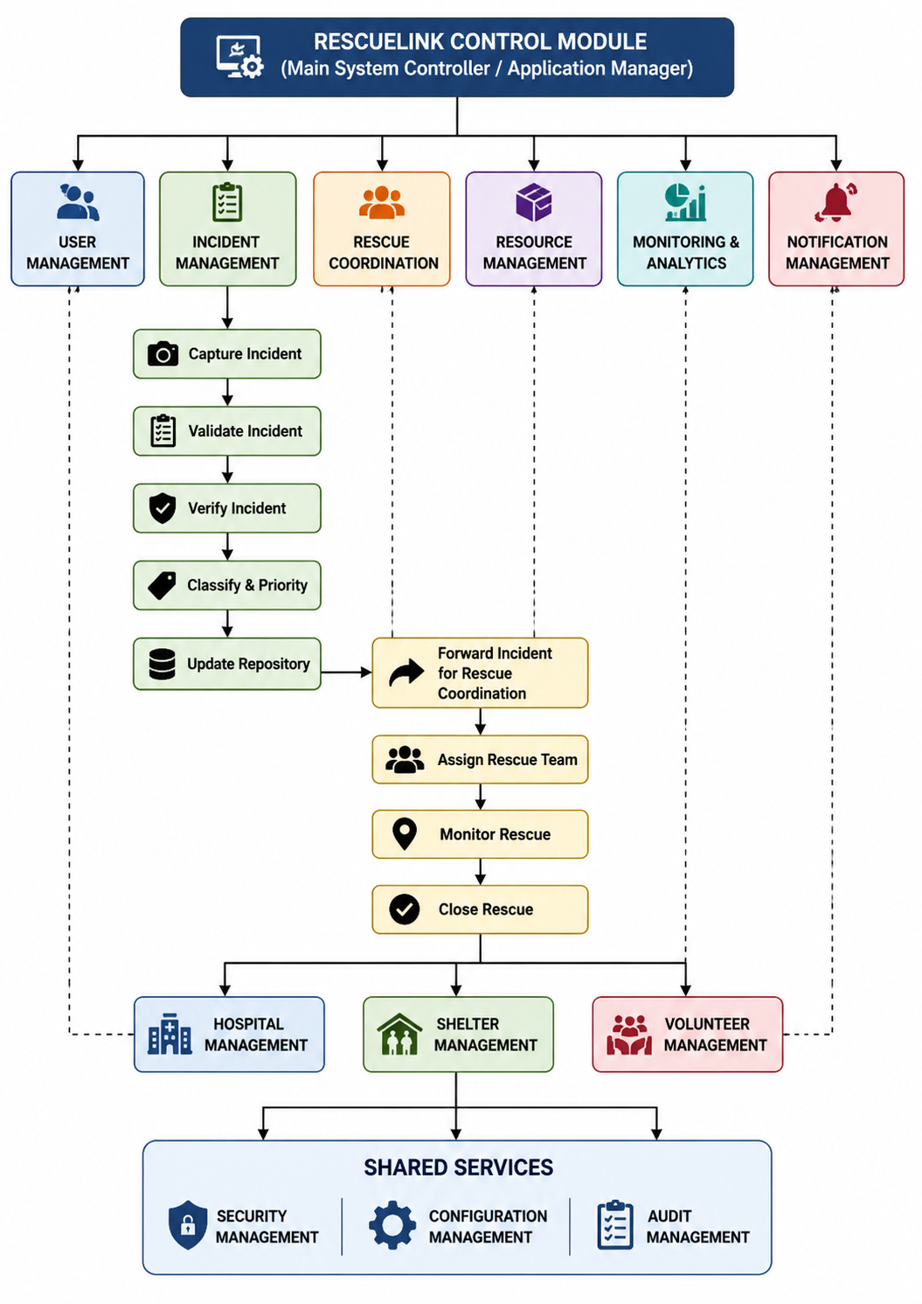

Hierarchical Explanation
Level 1 – Main Control Module
RescueLink Control Module is the root of the structure chart. It coordinates the execution of all major business functions and controls the overall workflow of the application.

Level 2 – Core Functional Modules
The control module invokes six major operational modules:
- User Management
  - Registration
  - Authentication
  - Profile Management
- Incident Management
  - Core business module
  - Handles the complete disaster incident lifecycle
- Rescue Coordination
  - Dispatches rescue teams
  - Monitors rescue progress
  - Completes rescue operations

- Resource Management
  - Maintains emergency resources
  - Allocates resources to rescue teams
- Monitoring & Analytics
  - Dashboards
  - Reports
  - Operational analytics
- Notification Management
  - SMS
  - Email
  - Push Notifications

Level 3 – Incident Management Submodules
The Incident Management module is decomposed into the primitive processes identified in the Level-2 DFD:
- Capture Incident
- Validate Incident
- Verify Incident
- Classify & Prioritize Incident
- Update Incident Repository
- Forward Incident for Rescue Coordination
These modules execute sequentially, reflecting the incident processing workflow.

Level 4 – Rescue Coordination Submodules
After receiving a verified and prioritized incident, the Rescue Coordination module performs:
- Assign Rescue Team
- Monitor Rescue Operation
- Close Rescue Operation
This module also interacts with:
- Hospital Management
- Shelter Management
- Volunteer Management
to support rescue activities.

Shared Service Modules
The following modules provide cross-cutting services to all functional modules:
- Security Management – Authentication, authorization, and access control.
- Configuration Management – System settings and operational parameters.
- Audit Management – Activity logging, auditing, and traceability.
These are infrastructure services and are not part of the primary business workflow, making them reusable across the system.

Parent–Child Relationships
Parent Module | Child Modules
RescueLink Control Module | User Management, Incident Management, Rescue Coordination, Resource Management, Monitoring & Analytics, Notification Management
Incident Management | Capture Incident, Validate Incident, Verify Incident, Classify & Prioritize Incident, Update Incident Repository, Forward Incident for Rescue Coordination
Rescue Coordination | Assign Rescue Team, Monitor Rescue Operation, Close Rescue Operation
Rescue Coordination | Hospital Management, Shelter Management, Volunteer Management
Shared Services | Security Management, Configuration Management, Audit Management

Verification Against Level-2 DFD
Level-2 DFD Process | Represented in Structure Chart | Status
2.1.1 Capture Incident Report | ✅ | Included
2.1.2 Validate Incident Information | ✅ | Included
2.1.3 Verify Incident | ✅ | Included
2.1.4 Classify & Prioritize Incident | ✅ | Included
2.1.5 Update Incident Repository | ✅ | Included
2.1.6 Forward Incident for Rescue Coordination | ✅ | Included

Structure Chart Validation
Validation Criteria | Status
Main control module at the top | ✅
Clear top-down decomposition | ✅
Parent–child relationships shown | ✅
Related modules grouped logically | ✅
Each module appears only once | ✅
Level-2 DFD functionality represented | ✅
High cohesion maintained | ✅
Low coupling supported | ✅
Suitable for implementation | ✅
Final Architectural Assessment
The final Module Hierarchy Chart follows Structured Design and Function-Oriented Design principles. It presents a clear top-down decomposition from the central control module to business modules, Level-2 incident-processing submodules, and shared infrastructure services. Each module appears exactly once, responsibilities are well separated, and the hierarchy directly traces back to the validated Level-2 DFD, making it suitable for software design documentation and implementation planning.

